Electronic Manufacturing and Prototyping

FULL WAVE RECTIFIER PCB LAYOUT REPORT

Presentation Title: Full Wave Rectifier PCB Layout

College: Indian Institute of Information Technology D&M,Kurnool

Student Level: Graduation

Presentation Type: Oral

Presentation at: IIITDM

Keywords: full wave rectifier, simulation, Multisim software, Ultiboard software, 3dside,3d silver screen, full wave rectifier, schematic,2d layout,3d areal,3d areal, 3d back, 3d copper traces, full wave rectifier copper top, full wave rectifier board outline, full wave rectifier coppertop copper bottom, full wave rectifier drill coppertop copper bottom, full wave rectifier silkscreen top, full wave rectifier silkscreen bottom, through holes.

Abstract: The Printed Circuit Board (PCB) is very important in all electronic gadgets, which are used either for domestic use, or for industrial purpose. [PCB design services](https://enventure.com/electronic-design/pcb-design-services.html) are used to design the electronic circuits. Apart from electrically connecting, it also gives mechanical support to the electrical components. The PCB designs can be created both manually and automatically. Manual layouts are created with the help of CAD drafting, and the automatic router helps in the creation of the designs automatically. The designers usually prefer the manual way of designs, since they can implement their own ideas and techniques in them.PCBs are the core component in almost all the electronic gadgets including the cell phones and the computers and laptops. With the increase in demand, the number of PCB services is on the rise. A few among those listed on top are the OrCAD PCB design and the Altium PCB design. Such designers generally offer a complete package of the PCB design services. This includes the PCB editor, the design capture technology, an interactive router, a constraint manager, interfaces for manufacturing CAD, and the component tools. The PCB editor edits the layers in the PCB, both single and multilayered. Both two dimensional and three dimensional rendering of the image are possible. 3D rendering is preferred, since it is possible to analyze both the inner and outer designs vividly.

Our project is to design a Full wave rectifier on PCB, we selected Multisim, Ultiboard software as our cad tools.

|  |
| --- |
| A Full Wave Rectifier is a circuit, which converts an ac voltage into a pulsating dc voltage using both half cycles of the applied ac voltage. It uses two diodes of which one conducts during one half cycle while the other conducts during the other half cycle of the applied ac voltage.  The full wave rectifier that is designed here consists of four diodes(1N4007),resistor(1kohm),resistance,HRD1X2connector,SPL0 ground.  **Software features to consider in PCB design software:**  The first thing that one should find out is if the PCB design software that is considering will do what we need it to do. In order to answer that question, we need to define what kind of design technology that we will be using it for. Will we be designing single layer, two-layer or [multi-layer boards](https://resources.altium.com/pcb-design-blog/multilayer-pcb-design-manufacturing-boards-for-high-voltage-pcbs)? Will these designs be for [power](http://blog.optimumdesign.com/switching-power-supply-pcb-layout-considerations-towards-a-better-switcher), [analog](https://www.slideshare.net/shovanakhanyusufzai/analog-design-considerations-in-pcb), [mixed-signal](https://resources.altium.com/pcb-design-blog/how-to-reduce-emi-in-mixed-signal-systems-using-proper-pcb-ground-designs), [high-speed](https://resources.altium.com/pcb-design-blog/an-overview-of-the-high-speed-pcb-design-guidelines-youll-need-for-your-pcb-layout), or [RF](https://resources.altium.com/pcb-design-blog/rf-interference-prevention-and-rf-pcb-design-in-the-internet-of-things) applications? A large complicated high-speed multi-layer design may require a more robust set of design tools than a small simple two-layer analog design. Knowing what kind of designs that we will be working on will give us the foundation for determining which design software is going to be our best choice.  Now that we’ve determined what kind of design work that we will need the software for, we need to evaluate the software in light of our entire design process. For instance, do we need a [schematic capture application](https://resources.altium.com/pcb-design-blog/high-speed-design-techniques-schematic-considerations), and if so does the new software have one associated with it? Does it contain simulation tools or have the ability to interface with external simulators? What kind of part [system](https://resources.altium.com/pcb-design-blog/complete--management-pcb-design) will these software tools require and how much work will it take to manage that? A failure to look into these kinds of details could put us in the awkward position of having to purchase more CAD software further down the line to get our job done.  Keeping all the required functions and necessity features in view, according to our convenience we select our PCB design software as Ultiboard software.  **About Ultiboard software:**  Ultiboard formerly known as ULTIboard is a program created by Ultimate Technology in the Netherlands. It was quite expensive as it would go for $800–$2500 depending on the size required. Additionally, the affordable version for students was limited in the market.    Over time, Ultiboard developed from a program that could barely produce photo plot files to when it was known as Electronics Workbench and now Ultiboard. An advanced platform which comes with schematic capture and simulation tool-Multisim facilitating users to easily design PCB models, manipulate than to products ready for the manufacturer.  **1.1 Functions of Ultiboard software:**  Ultiboard is mainly used for its benefits:   • Easy to use and efficient PCB layout program- routing tools for PCB designs; customizable and accessible features    • Optimum control and management of the environment- Ultiboard has advanced spreadsheet view, toolbox, design wizards and other tools improving functions such as copper placement and the general board layout.   • Transfer of simple schematics to PCB- Ultiboard integration with Multisim™ provides features and tools that facilitate precise placement of parts as well as automated functionality for the fast working of the layout design.   • File Standardization-You can export your design file in one format such as DXF or Gerber to another format that is required for standardization purposes.   Ultiboard main objective is to provide flexibility regarding control, efficiency and speed in layout, routing tools and copper placement. It is used by engineers, manufactures, students as well as teachers in different environments. Let us have a look at how we can get access to Ultiboard that is, how to download and install.  **1.2 Ultiboard download**  Instead of downloading Ultiboard and later during installation, realize your system lacks a number of requirements. Generally, to install Ultiboard 9 you require about 150mbs. However, this varies depending on the version you need. Also, your system should at least have:   •Windows 2000/XP   •Pentium III Processor   •128 MB RAM   •CD-ROM   •800 x 600 screen resolution  We can get the version of any Ultiboard professional or academic product in the National Instruments website. The installation is simple and similar to most application installation processes. Having installed Ultiboard, you need to get familiar with the software interface to interact with it optimally. Our next will focus on basic to standard components that you need to identify before you begin designing.  **1.3 Introduction to the Ultiboard Interface:**  The Ultiboard interface is a combination of tools and features that aid you, the user, to maneuver around in designing your circuit or PCB layout. It facilitates creativity and innovation of new and original designs that will improve the electrical production industry. Ultiboard interface offers a platform for automatic placement of parts in creating your PCBs, manually designing CAD operations to their manufacture.    The user-friendly interface has brought speed thanks to the automated functionality. Also, precision can be achieved in the placement of parts in the correct position due to manual control. Together with Multism, Ultiboard results to generations of further advanced and better-performing PCBs. Why? Mutism compliments Ultiboard PCB layout and routing abilities through its powerful SPICE simulation functionality. You can get started with your design in no time. 1.4 Toolbars: If you have used any common application such as MS word, Ultiboard toolbars will not be rocket science. Most of the symbols are ones you are already familiar with, in case of any new ones, you can hover around the icon to know their function. Nevertheless, here is a guideline: Main toolbar Select icon –Select an element from the board  Design Toolbox icon –‘Switches’ the Design Toolbox view on and off    Spreadsheet View icon –‘Switches’ the Spreadsheet view on or off    Database Manager icon –Displays the Database manager view    Board Wizard icon –Start Board Wizard   * The place from the database -Browse the database for a position to place an element   Line icon –Place a straight line on the design    Follow-me icon –Place a follow-me trace    Polygon icon –Places a polygon on the design    Power plane icon –Places a power plane on the design.     * DRC and netlist check icon –Runs the DCR (Design Rule Check) and Netlist Check; It displays the results in the Results tab     Text icon –Places text on the design    View 3D icon -Displays the design on display in three dimensions.    Capture screen area icon – Captures a section of the screen and places it on the system clipboard    Help icon –Displays the Ultiboard Help window   Edit toolbar In-place part edit icon –Activates In-Place Edit for placed PCB parts    Swap layer icon –Places a part or element on the mirror layer 1.5 Setting Preferences To set your setting preferences:   1.Click on the Options/Global Preferences for the Preferences dialogue box to appear which will provide you with the options:   ♦ General Settings Tab   ♦ Paths Tab   ♦ Colours Tab   ♦ PCB Design Tab   ♦ Dimensions Tab   ♦ 3D Options Tab   2.Having selected the desired tab, go ahead and customize or edit the details.   3.Click OK to save your changes   1.6 Setting PCB Properties To set the settings of the PCB properties:On an empty board, right-click to display a menu-box and select the property icon. The Sheet Properties dialogue box will appear where you can further edit your PCB details as desired.     1.7 Design Toolbox You are most likely to use the Design toolbar to manage your design in controlling parts such as in determining colours of a trace. To display or view it, click on the Design Toolbar. 1.8 Spreadsheet View    The Spreadsheet view is essential in viewing and editing details such attributes, footprints or Reference Designators.   To access the Spreadsheet View icon, you have to have a new project open. Once you click the icon, the functionality tab will appear at the most bottom of the pages, and it has a number of buttons/icons.   However, not all tabs have all the icons. 1.9 Customizing the Interface To customize your interface:   Select Options/Customize User Interface to display a menu tab as shown below, where you can make changes as desired.  We have covered the fundamental orientation steps of how you can customize Ultiboard to your liking and use of different icons. Therefore, our next step will be to learn how to design a simple schematic and further employ more features and properties of the software during the process.   2.1Ultiboard Design Tutorial 2.1.1The Electronics Workbench Suite It is an EDA suite that facilitates major steps in designing a circuit. Depending on your requirements and budget, you will have some of the components of the Electronics Workbench Suite such as:   • Mutism: it is a combination of the Muticap and both analogue and digital simulation capability   • Multicam: a schematic product for driving simulation, simple schematic and facilitating steps such as in Pcb layout designing.  • MultiVHDL: It brings on board co-simulation along with Multism and creation of HDL models.   • Ultiboard: a product that alongside from Multism and Multicap, is useful in the creation of PCBs and working on CAD operations mechanically. 2.1.2 Opening the Tutorial To open the tutorial, ensure the Ultiboard is launched then proceed to:   1.Select on Open/File icon. Go to where you stored your Ultiboard during installation (in case you cannot remember to try the main disk C in the program files).   2.Open the Tutorial.EWPrj to load the selected file on the Ultiboard   3.To view a design, select it either by clicking the design tab or the Projects tab under the Design Toolbox      **2.1.3 Creating a Board Outline**  You can create a border outline in the following ways:  Using the drawing tools- press the keyboard * and fill in your desired border outline coordinates:       Import a DXF file    • Use the Board Wizard which we will use in this tutorial:   1.Along the toolbar layer, go to the Border Wizard icon and double click on it.   2.Delete the existing Boarder wizard in the existing- it should be a new one for the Board Wizard-Board Technology box to appear.   3.Enable the ‘Change the layer technology' to be able to select other options. Go ahead to choose ‘Multi-layers constructed with double-sided boards and single layer stack-ups' then click the Next tab.       1. The next dialogue box is of Lamination Settings where you can make changes if necessary and click.The next Dialog box is the Shape of Board where you will make the changes as:   • Under the Reference Point, set the Alignment to the Left-Bottom  • Select the Rectangular for Board Shape and Size  • Set the Height and the Width as 2000 and 2500 respectively and the Clearance at 5.00000. Click Finish.      **2.1.4 Editing changes on the Border Outline**  To move the Boarder outline:  Double-click on Board Outline under the Layers tab. Proceed to click anywhere on the workspace border outline, below the row of components.  To make changes on the Reference point:  Click on the Options tab, place your cursor on the bottom-left of the border outline on the board and click to make changes on the box that appears 2.2 Placing Components You can place a component on the board by:    • Select a component(s) beyond the border outline and drag it in the desired position   • Go to the Spreadsheet View, use the Parts tab to locate a component(s) and place them appropriately   • Import component(s) from Netlist   • You can select the component(S) directly from the database   • Use the auto place 2.3 Placing Traces There are a few ways you can place traces:  Placing a manual trace  Here, the trace is positioned where you place it. To do this:   • Choose the Line /Place command to create a line which will depend on the layer (in the drop box)you are to place the line.   • Click to anchor the trace and proceed to move the cursor towards the destination where you will also click to anchor again or right click to stop the drawing. 2.4 Placing a Follow-me Trace A follow-me trace allows you to draw a trace between two pins you have selected by simply moving your cursor. It is achieved by:   • Click on the follow-my icon; ensure you have at least two appointed pins   • Click on one pin, then click on another pin for the Ultiboard to automatically draw the pin for you 2.5 Placing a Connection Machine Trace The connection machine trace provides complete trace automation of by joining two points through the most convenient route. It is achieved by:   • Click on Place/Connection Machine icon   • Proceed to click on the space between the points you want connecting. Ultiboard will provide various route suggestions and once you identify the suitable trace, click to use it   • Right click to end the trace placement 2.6 Preparing for Manufacturing/Assembly Before submitting your designs for manufacturing, there are a number of activities that you can perform on the board to ensure you provide extra information or remove errors. They include: 2.6.1 Cleaning up the Board That involves cleaning up open trace end or any unused parts or connections. It is done by:   • Click on the Edit/Copper Delete/Open Trace Ends to delete all open trace ends.   • Click on the Design/Clean Unused Vias to delete any unused vias or connections 2.6.2 Adding Comments Adding components are important in providing extra information that the manufacturer can refer to or promote collaboration among team members. You can place a comment by:   • Activating the comment layer in design box   • Select Place/ Comment and a dialogue box will appear as below:     • You can choose to fix the background size or make other edits such as the font style and size or text and background colour.   • Type the comment as in the comment box   • Click OK. Proceed to double-click on the desired position for the comment to appear.   • To make any changes, go back to the comment dialogue box and edit any details as you wish and delete the previous comment that is not wanted.   • To delete a comment click on the comment and press the key DELETE 2.6.3 Exporting a File It is usually the final process which is producing your design as an output. It is transforming the design format to another that is understandable by the equipment of the manufacturer. The file contains detailed information on how the design should be manufactured.    The formatting requirements of the manufacturer mainly dictate the format. Exporting a file begins by pressing Ctrl-E or clicking the File tab, and a menu will appear which among the list is the Export option.    An Export dialogue box will appear where you can view, export or delete the export settings/properties. 2.7 Viewing Designs in 3D You can view your design in 3D by:   Click on the 3D icon which is listed in the Tools menu. A 3D preview tab will show displaying your design in 3D will show.    2.8 Manipulating the 3D View • Click on the Tools bar then 3D to view the 3D preview.   • Proceed to click on the preview board and hold on the mouse/cursor and move to:   • Move the pointer of the screen to either side of the screen for a better or specific view of the board   • To pan the 3D wheel, hold down the cursor to view the four-headed arrow and point the desired direction    • To move the 3D view around, click and hold on it   • Proceed the pointer either direction to have a view of the design's other sides; topo underside of the board   • To zoom in on an area: Click and hold onto the cursor and move/scroll it up or down  • Also, you can use the Zoom in/out under the View tab.   Hopefully, by now you can comfortably maneuver the Ultiboard platform, are familiar with different icons, tabs and their property. Also, ultimately you should be able to create a simple design as was our goal when we began. 2.9 Advantages and Disadvatages of Using Ultiboard   **2.9.1 Advantages of Using Ultiboard**  • It is user-friendly and intuitive   • Can be integrated with other tools such as spreadsheet as well as used in managing constraints, copper routing, and part placement.   • It is easy to use and is optimized for speed   Can be exported to industry standard including Gerber and DXF for both manufacturing and prototype.    • It transfers schematic layouts since it is seamlessly integrated with Multism.   • It allows you to quickly gain insight into how to design your PCB.   • It annotates the changes made to the design.    **2.9.2 Disadvantages**  Despite the many benefits that you get when you use Ultiboard, it is important to note that it comes with a host of disadvantages. The most critical one is:   • It requires plenty of training to be able to use it.   • It is not a free tool and so you must be prepared to dig deep into your pocket  **2.10 How it Works**  When it comes to layout routing, choosing Ultiboard is recommended. Since it comes with an automated part and manual placement routing. The tools combine to reduce time and effort needed in completing repetitive tasks. When combined with placement process, it guarantees a quick layout. Ultiboard comes with trace placement that allows for quick and efficient adjustment based on the complexity and the design.    It quickly finds and places components in the schematic since it comes with the pick and place functionality. It utilizes the follow me router and machines that input suggestions to the trace placement. When integrated with Multisim. It utilizes the auto-routing which allows easy schematic transfer of layout that is reflected in many versions of the design. It, therefore, allows for the provision of easy and quick flow of design and validation.  **Full Wave Rectifier:**  A Full wave rectifier is a circuit arrangement which makes use of both half cycles of input alternating current (AC) and converts them to direct current (DC). In a half wave rectifier makes use of only one-half cycle of the input alternating current. Thus a full wave rectifier is much more efficient (double+) than a half wave rectifier. This process of converting both half cycles of the input supply (alternating current) to direct current (DC) is termed full wave rectification**.**    **Full Wave Rectifier – Working & Operation**  The working & operation of a full wave bridge rectifier is pretty simple. The circuit diagrams and waveforms we have given below will help you understand the operation of a bridge rectifier perfectly. In the circuit diagram, 4 diodes are arranged in the form of a bridge. The transformer secondary is connected to two diametrically opposite points of the bridge at points A & C. The load resistance RL is connected to bridge through points B and D.      **Components Used & Schematic Representation Of Full wave Rectifier:**      **1N4007 Features and Mechanical Data:**    **Features:**    **Mechanical Data:**    **Maximum Ratings and Characteristics:**    **Ratings and Characteristic Curves:**    **Through hole default measurements:**    **Full Wave Rectifier in Multisim:**    **Full Wave Rectifier layout in Ultiboard:**    **3D-side of fullwave Rectifier in Ultiboard:**      **3D-Silver screen of FullWave Rectifier in Ultiboard:**    **2D-Layout of Fullwave Rectifier in Ultiboard:**      **3D-Areal View of Fullwave Rectifier in Ultiboard:**    **3D Back view of Full Wave Rectifier in Ultiboard:** |

|  |
| --- |
| **3D-view of Copper Traces in FullWave Rectifier in Ultiboard**: |
|  |

**Necessity of Gerber files:**

Initially developed by a company with the name of *Gerber*, Gerber format currently refers to a widely accepted standard PCB industry software sticks to, capable of describing circumstances of board images such as conductor layers, soldermask layers, legend layers.

Printed circuit boards are designed in a specialized EDA (Electronic Design Automation) or a CAD (Computer-Aided Design) system that further generate board manufacturing data based on which circuit board fabrications are commenced. PCB manufacturers won't fully understand all details of a PCB design file unless Gerber format file is contained in it as reference and guidelines. Gerber format file is applied to describe design requirement of each image of a circuit board and it can be applied for both bare board fabrication and PCB assembly.

When it comes to [bare board fabrication](https://www.pcbcart.com/pcb-fab/standard-pcb.html), Gerber format is called for by both standard photoplotters and other manufacturing equipment desiring image data like legend printers, direct imagers or AOI (Automated/Automatic Optical Inspection) equipment etc. put it simply, Gerber format files have to be depended from beginning to the end of PCB fabrication process.

When it comes to [PCB assembly](https://www.pcbcart.com/assembly/overview.html), a stencil layer is included in Gerber format and component locations are regulated as well, which will be regarded as significant reference data for SMT (Surface Mount Technology) assembly, thru-hole assembly and mix of them.

## Versions of Gerber Files

Nowadays, three versions of Gerber formats are available:

• Gerber X2 - the newest Gerber format with stackup data and attributes contained.

• RS-274-X - an expanded version of Gerber format and it has been widely applied.

• RS-274-D - the oldest version of Gerber format which is being gradually replaced by RS-274-X.

## Gerber Files Generation

PCB design engineers should never be too lazy to generate their own Gerber files for the following two reasons.

You are hardly able to make sure the [PCB design software](https://www.pcbcart.com/article/content/design-software-survey.html) you're using is the same as that is being used by your PCB manufacturer. If your PCB manufacturer uses different PCB design software, you have to generate Gerber files by yourself, further conversation and confirmation will definitely cause more time and delay the production process accordingly.

Even if PCB manufacturer uses the same PCB design software as you do, you are still advised to generate Gerber files on your own since difference in terms of applied software may also lead to possible errors.

Therefore, in order to ensure delivery time and reliability of end products, PCB design engineers should learn to generate Gerber files on their own. Gerber files generally contain design data of conductor layer, soldermask layer and silkscreen layer. Furthermore, when it comes to two layers with the same design data, Gerber files should be still generated respectively to avoid possible misunderstanding.

Different PCB design software feature different operation steps of Gerber files generation. In the following part of this article, Gerber files generation methods will be displayed concerning PCB design software.

NI Ultiboard has a standard **Export** dialog box to export a set of Gerber files.

**The Export Dialog**

The Export dialog box is a simplified dialog box that you can use to establish the different parameters required by different manufacturers for the final file export.

This tutorial uses a shipping example to showcase the export process.

1. Select **File >> Open Samples**.
2. Select **Intl4lRouted.ewprj**.
3. Click on the **Open** button.

You are now ready to view the export dialog box.

1. Choose **File»Export**. The Export dialog box appears as seen in figure.You can see in the dialog box the various types of formats and reports that can be exported from NI Ultiboard for manufacturing purposes. This tutorial focuses primarily on the Gerber RS274X options, as this is one of the most common outputs for manufacturing purposes.

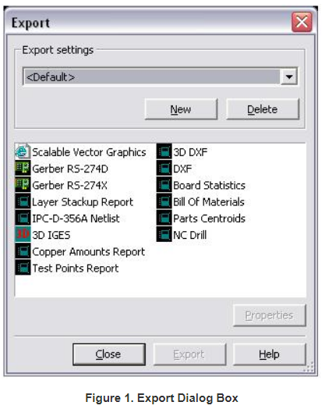

**Exporting a Gerber File**

With the Gerber properties (RS274X or RS274D) dialog box, you can select the layers to be exported, the number of digits in numerals, and the kind of measurements.

1. In the Export dialog box select **Gerber RS274X** and click the **Properties** button.

In Figure 2 below, you can see the various parameters that can be set to configure your Gerber file export.

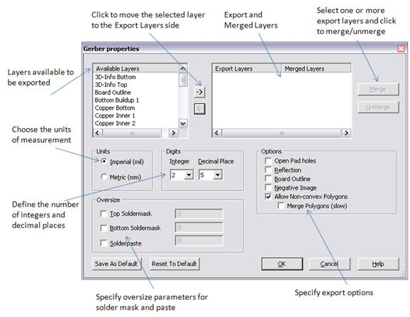

**Geber file parameters:**

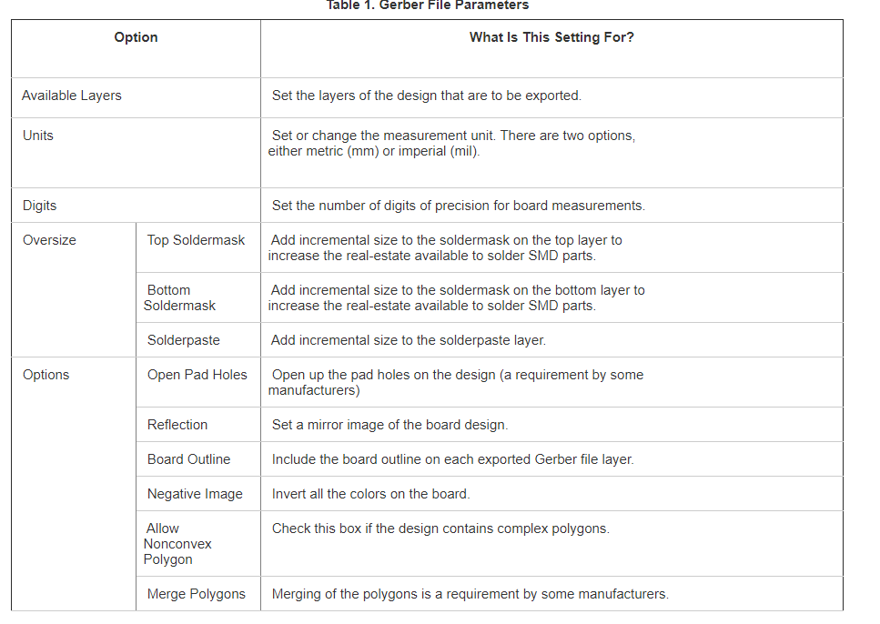

**Selecting Layers to Export**

1. To select multiple layers at once, hold down the **<CTRL>** key while selecting.

The following are typical Gerber files needed to produce the board:

* All copper layers
* Soldermask Top/Bottom
* Silkscreen Top/Bottom
* Board Outline

Once you have selected all of the necessary layers, click the **right** arrow (highlighted in red in Figure 3 below), to add the selection to the **Export Layers** list.

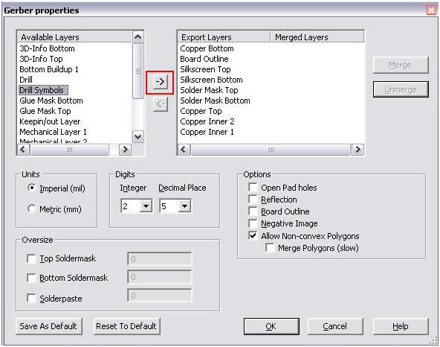

With the layers selected (and any other option set, such as units, digits, options, oversize, and so on) you are ready to export the Gerber files.

Click on the **OK**button to save the settings and exit the properties dialog box.

**The Export Process**

1. To finally export the various layers of your design, click on the **Export** button in the export dialog box (as seen in Figure 1).

Ultiboard directs you to the Create aperture mapping dialog box (Figure 4). For **Gerber RS274X** files, there is no need to edit the aperture settings as they are automatically set by the export process.

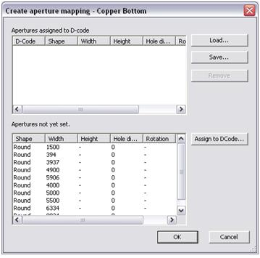

1. Click on the **OK** button to finalize the export.
2. Ultiboard directs you to save the exported gerber file. Select a destination folder and click on the **Save** button to finalize the location of the export.

Ultiboard now cycles through all the layers, and allows you to set the aperture settings and file locations for each layer of the design. This means repeating Steps 8 and 9 for each layer.

**5. Viewing the Gerber File**

Ultiboard includes a built-in Gerber Viewer that you can use to verify the production files created.

Simply go to **File»Open** and select a generated Gerber files.

Click on the **Open** button.

You can now view the exact file that the manufacturer views, as can be seen in Figure below.

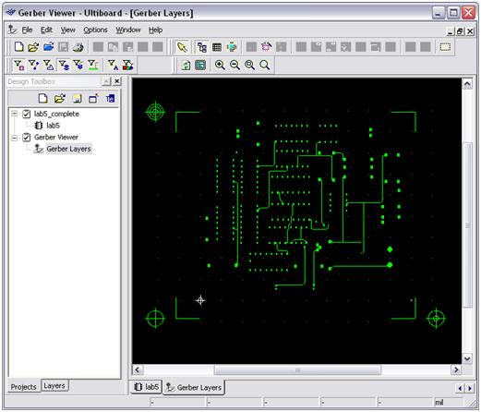

**Figure**

**Silverscreen top layer of FullWave Rectifier in Ultiboard GBR file:**

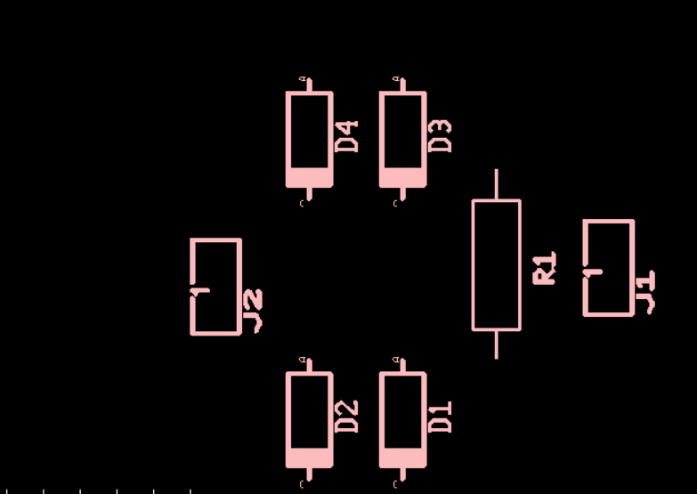

**Silverscreen Bottom layer of FullWave Rectifier in Ultiboard GBR file:**